PHD VIVA VOCE
Candidate Name: | Manini Wakuru | 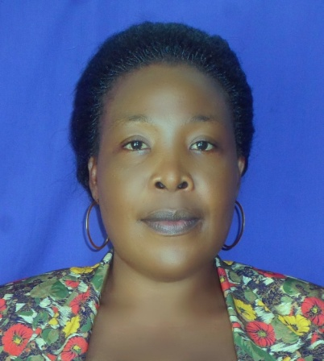
Registration Number | 2015-07-00207  School of Education, UDSM
Qualifications attained:
Tutor, Patandi Teacher’s College of Special Education Needs 2004 to date
Master of Arts in Education (Curriculum), University of Dar es Salaam 2014
Bachelor of Arts with Education (Hons), Dar es Salam University College of Education (DUCE), 2008-2011
Advanced Certificate of Secondary Education, Korogwe Teacher’s College, 2007-2008
Special Certificate of Theatre Arts, Butimba Teacher’s College, 2002-2004
Certificate of Secondary Education, Mwembeni Secondary School, 1993
Certificate of Primary Education, Iringo Primary School, 1983-1988

Title of Dissertation/ Thesis: | “Teachers Classroom Practices on Improving Learning and Participation of Pupils with Moderate Deaf-Blindness in Tanzania Inclusive Primary Schools ”
Date of Viva Voce: | 24thJuly, 2020
Venue: | Board Room, SoED
Time: | 10.00 a.m.
Supervisor | Dr. Mwajuma Vuzo
Abstract:
For inclusion to be successful teachers need to change their perceptions and instructional practices to optimise all pupils’ potential in inclusive classrooms on a non-discriminatory basis. This study explored teachers’ classroom practices for improving the learning and participation of pupils with moderate deaf-blindness in Tanzanian inclusive primary schools. Guided by the Social Model of Disability (SMD), this study was especially conducted in order to: (i) explore primary school teachers’ understanding of the learning needs of pupils with deaf-blindness in inclusive classrooms, (ii) examine teachers’ perceptions of the inclusion of pupils with moderate deaf-blindness, (iii) examine teachers’ instructional practices used to teach pupils with moderate deaf-blindness in inclusive classrooms, and (iv) assess barriers to teaching that teachers encounter when teaching pupils with moderate deaf-blindness in inclusive classrooms. The study was underpinned by the constructivism philosophy using the qualitative research approach with the multiple-embedded case study design. Data were collected through semi-structured interviews, classroom observations, focus group discussions (FGDs) and documentary review. Four inclusive primary schools were purposively sampled from three districts in Mainland Tanzania. The sample included 68 participants: four heads of school, four academic masters/mistresses, four special heads of SEN Unit, 32 regular education teachers, eight special education teachers, eight pupils with deaf-blindness and eight non-disabled pupils. The findings revealed that the majority of teachers lack understanding of the learning needs of pupils with deaf-blindness, and lack appropriate inclusive pedagogical skills that could be used to enhance the learning and participation of pupils with moderate deaf-blindness. This lowers teacher’s self-confidence and commitment and has the potential to contribute to burnout as they attempt to provide appropriate instructional support and services to enhance the learning and participation of these pupils. The study further found that a vast majority of teachers posess medical-pathological views of pupils with deaf-blindness and were more unenthuastic to accept individual differences in learning process.The findings further revealed that the overwhelming majority of teachers are faced with various barriers when teaching pupils with moderate deaf-blindness, such as the difficulty in communicating with these pupils, the limited time allocated to the teaching period, the inaccessible physical environment and curriculum, the acute shortage of teaching and learning resources, and teachers’ negative perceptions. It is, therefore, recommended that any endeavour to address teachers’ exclusionary practices should be done multi-dimensionally by minimising barriers to teaching and learning, and promoting collaborative practices among regular and special education teachers. The Ministry of education, Science and Technology (MoEST) in collaboration with other education stakeholders should consider restructuring teacher education curricula to align with the principles of IE, providing policies on IE and ensuring in-service training for teachers on IE. The study contributes to the existing body of knowledge regarding appropriate classroom practices for pupils with moderate deaf-blindness in inclusive classrooms along with recommending lines for future research.

Panel Members:
No | Name | Designation | Rank | Unit
1. | Prof. E.P. Bhalalusesa | Chairman | A/Professor | EMFLL-SoED
2. | Dr. Septimi Kitta | Representing External Examiner | S/Lecturer | EPCS-SoED
3. | Dr. Wadrine Maro | Head of the relevant Department (or his/her appointee) | Lecturer | EPCS-SoED
4. | Dr. Rebeca Sima | Internal Examiner | S/Lecturer | EPCS-SoED
5. | Dr. Mwajuma Vuzo | Candidate’s Supervisor | Lecturer | EPCS-SoED
6. | Dr. Sarah E. Kisanga | Candidate’s Supervisor | Lecturer | EPCS-SoED
7. | Dr. Albert Tarmo | Co-opted Member (appointed by College/School/Institute | Lecturer | EMFLL-SoED (Coordinator)
8. | Dr. B. Kanukisya | Co-opted Member (appointed by College/School/Institute | S/Lecturer | EMFLL-SoED
9. | Dr. Maregesi Machumu | Appointee of the Principal for PhD only) | Lecturer | EPCS-DUCE

